Student’s name | …………………………………………………….…… | Grade | 1
Subject | Computer | Week No. | 9
Lesson Title | Type with keyboard | Unit
Worksheet No. ( 9 ) (Answer)

write the correct name of each part
Enter
Space
keyboard
Notepad

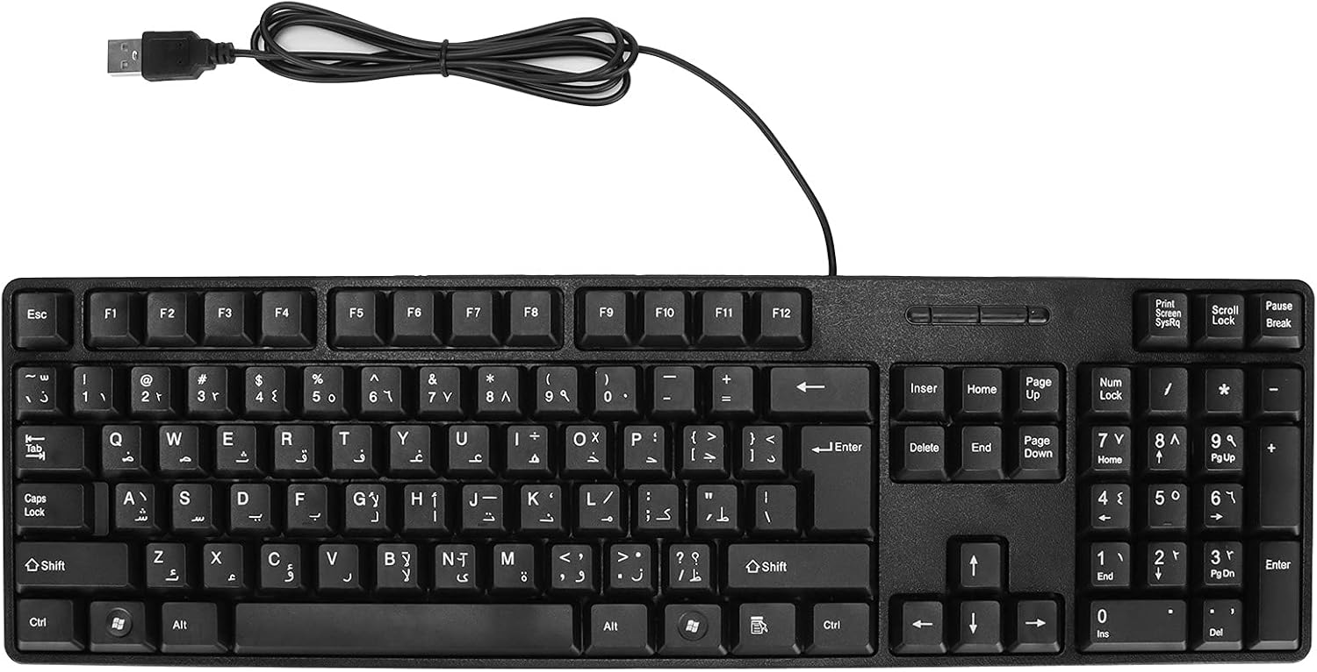


Space
Enter
Notepad
keyboard
Good Luck

